OpenSSL - Installation under Windows

In some situations, it can be useful to generate a CSR using OpenSSL. This manual describes the installation of OpenSSL under Windows.

1. Download the [OpenSSL for Windows installation package](https://wiki.openssl.org/index.php/Binaries).
2. Double-click the installation file.
3. If the following error message appears, you should install Microsoft Visual C++ 2008 Redistributables. The installation file can be downloaded [here](http://www.microsoft.com/en-us/download/details.aspx?id=29). 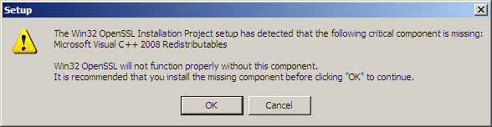
4. Double-click the installation file and click on Next 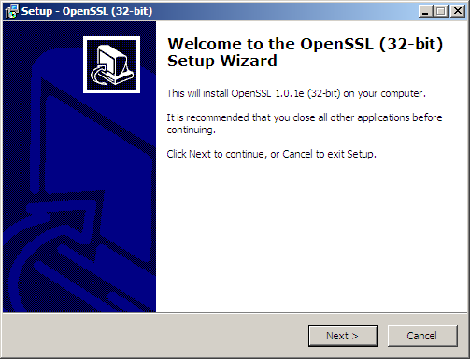
5. Click on I accept the agreement, followed by Next. 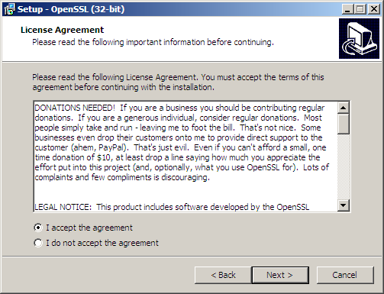
6. Leave the default installation path (C:\OpenSSL-Win32) and click on Next. 
7. Leave the default Startmenu folder(OpenSSL) and click on Next. 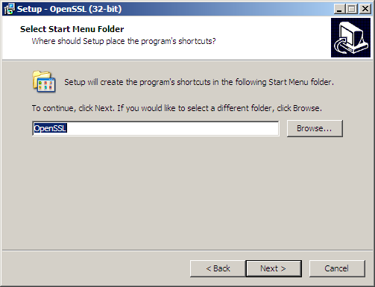
8. Leave the The Windows system directory and click on Next. 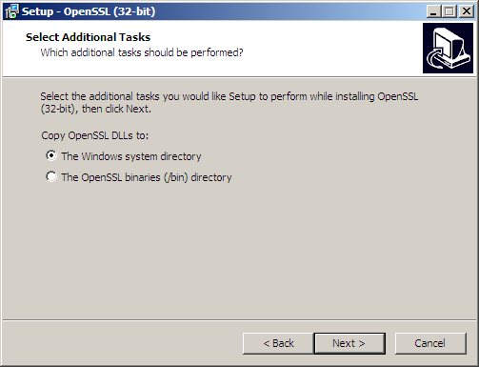
9. Click on Install. 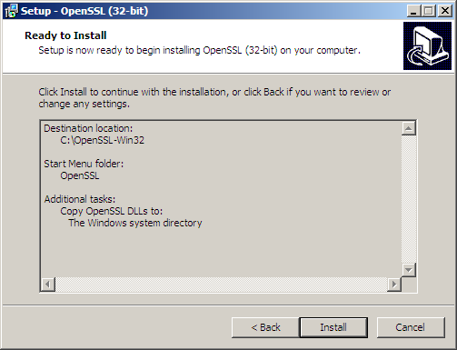
10. Click on Finish once the installation has been completed.

OpenSSL for Windows has now been installed and can be found as OpenSSL.exe in C:\OpenSSL-Win32\bin\. Always open the program as Administrator.   
Note: The following error message might appear when running OpenSSL:

WARNING: can't open config file: /usr/local/ssl/openssl.cnf

This can be solved as following:

1. Close OpenSSL.
2. Open a Command Prompt (CMD) as Administrator
3. Run the following command:SET OPENSSL_CONF=C:\OpenSSL-Win32\bin\openssl.cfg
4. Reboot the computer

Document from :

<https://www.xolphin.com/support/OpenSSL/OpenSSL_-_Installation_under_Windows>

En cas de besoin contacter Terrien Simon.